# DAY 3 TASK

1.Create a component named “author” which has 3 fields

* Author Bio

|  |  |  |
| --- | --- | --- |
| Name | Type | Value |
| Jcr:title | string | Author Bio |
| Required | Boolean | true |
| name | string | ./authorBIo |
| Sling:resourceType | string | Granite/ui/components/coral/foundation/textarea |

* Author Name

|  |  |  |
| --- | --- | --- |
| Name | Type | Value |
| Jcr:title | string | Author Bio |
| Required | Boolean | true |
| name | string | ./authorName |
| Sling:resourceType | string | Granite/ui/components/coral/foundation/textfield |

* Date of Birth

|  |  |  |
| --- | --- | --- |
| Name | Type | Value |
| Jcr:title | string | Date of Birth |
| Required | Boolean | true |
| type | string | Date |
| Sling:resourceType | string | Granite/ui/components/coral/foundation/datepicker |

Dialog Structure

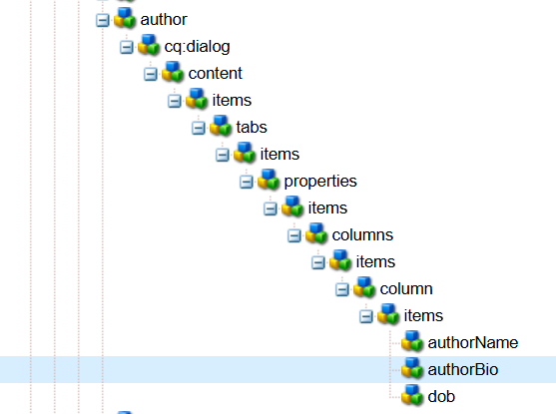

Component Display

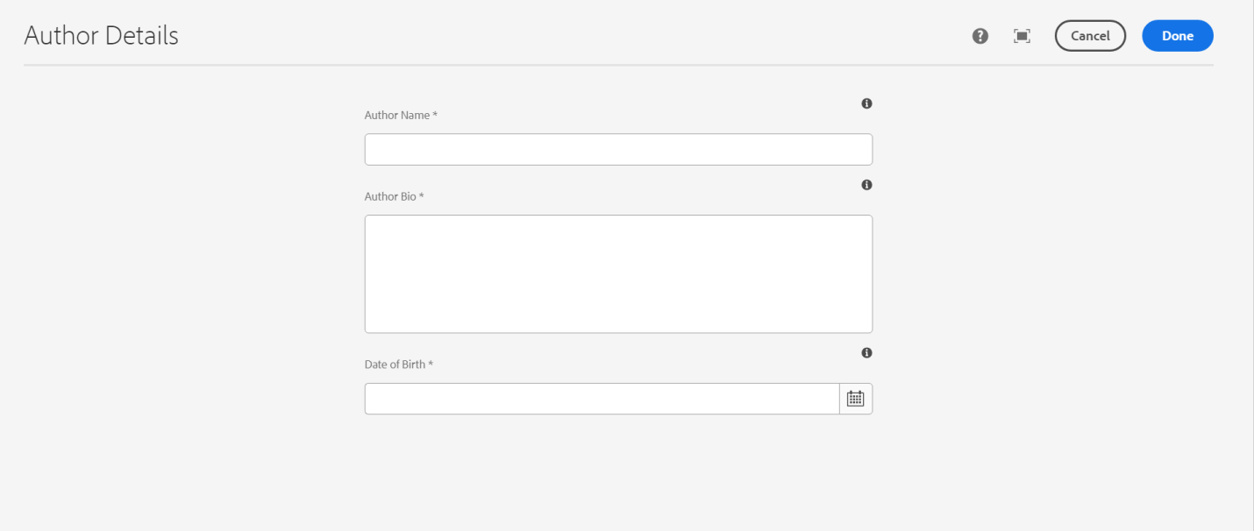

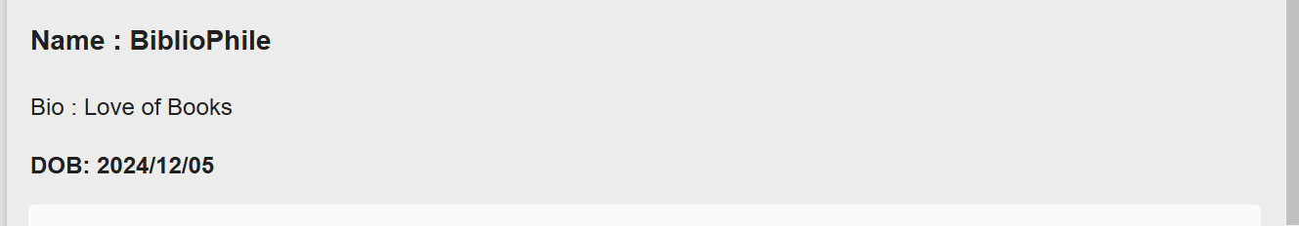

**Steps to create clientLibs**

1. extraClientLibs is an AEM property used to load additional CSS/JS in a component’s dialog for styling or custom functionality.
2. Create a client library under /apps/myproject/clientlibs/clientlib-author-dialog with categories=["myproject.author.dialog"].
3. Add CSS & JS files inside css and js folders, and reference them in css.txt and js.txt.
4. Link it in the dialog by adding extraClientLibs="[myproject.author.dialog]" inside _cq_dialog.xml.
5. Test it by opening the component’s dialog in AEM Page Editor to see the applied styles or scripts.